User Instructions for RingCentral Conference Bridge
- As a host, we recommend that you read and be familiar with these instructions the day before the event and not wait until the day of your Lunch & Learn event. If you have any questions, please reach out to support@lunchandlearn.cloud
- You will receive the RingCentral login URL from support@lunchandlearn.cloud
- It is your responsibility as the host to distribute this URL in a calendar invite to all the attendees
- It is HIGHLY recommended that you utilize a headset or high-quality headphones.
Day of the Lunch & Learn:
- It is recommended that as the host, that you log into RingCentral at least 10 minutes prior to the start time
- If you have not used RingCentral prior to this event, you will need to download the application. To do this, just click on the URL for the Lunch & Learn and follow the instructions
- Once the application is installed, it will automatically launch
- The “Choose ONE of the audio conference options” window will appear. You will see two tabs:
  - Computer Audio: By clicking the green “Join with Computer Audio” button you will be connected to the Virtual Lunch & Learn
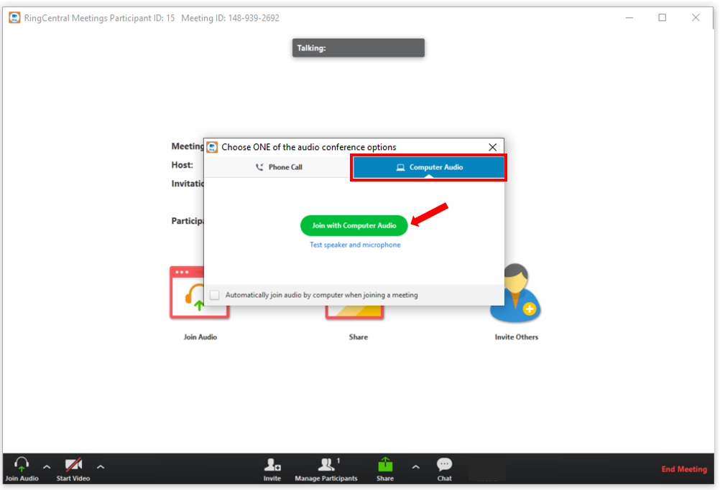
  - Phone Call: On this tab you will see:
    - Phone #’s to dial into
    - Meeting ID – Each meeting has a unique meeting ID# to enter
    - Participant ID - Each meeting has a unique participant ID# to enter
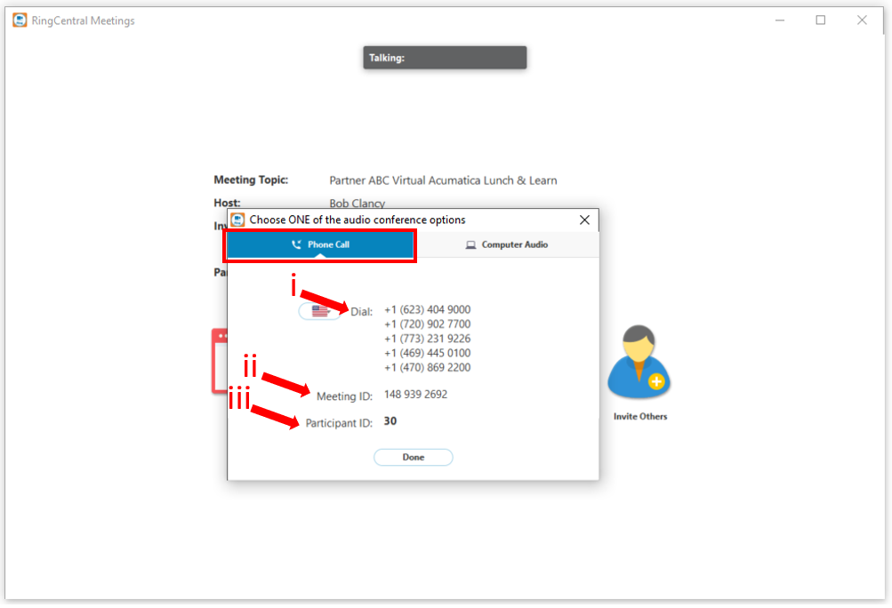
- After you have selected your audio option, you will be placed into the RingCentral meeting. In the main area of the window you will see:
  - Meeting details: This displays all the information related to the meeting. You can also click the “Copy URL” hyperlink if you need to send to an attendee
  - Join Audio button: If you need to switch your audio connection type (computer audio vs. phone call)
  - Share button: This will enable you to share your screen (see step #6 below for details on how to do this)
  - Invite Other button: This will allow you to invite others to this meeting (see step #7 below for details on how to do this)
  - Toolbar:
    - Mute: Clicking this will “mute” & “unmute” your audio
    - Start Video: If you have a video camera attached to your computer, you can click this to turn on or off your camera. By default, the camera is turned off
    - Invite: Same functionality as step “d” above
    - Manage Participants: Clicking this will open the “Participants” pane (see step #8 below for details on how to do this)
    - Share: Same functionality as step “c” above
    - Chat: Clicking this will open the “Chat” pane (see step #9 below for details on how to do this)
    - End Meeting: Clicking this will remove you from the meeting and End the meeting
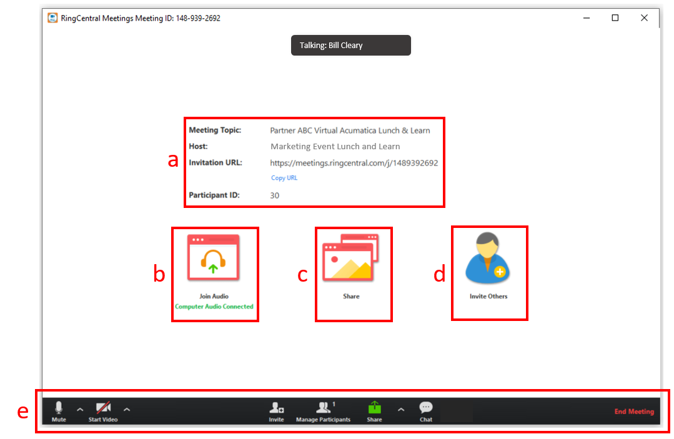

- Share Screen:
  - Click the “Share Screen” button
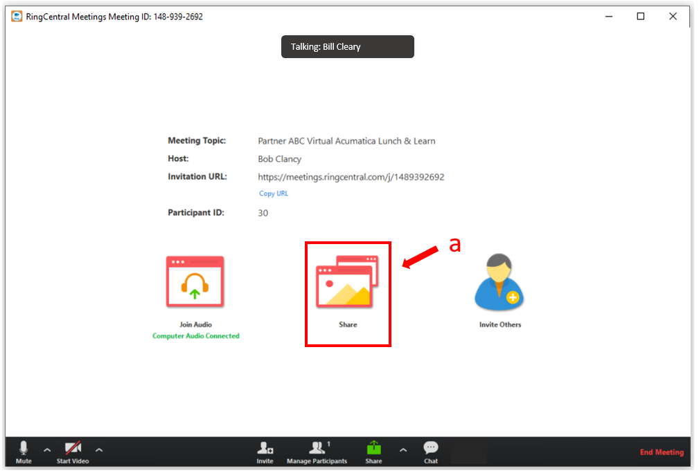
  - A window will open that will allow you to select:
    - A specific screen
    - A specific application
  - Once you have selected what you want to share, you will need to click the blue “Share” button.
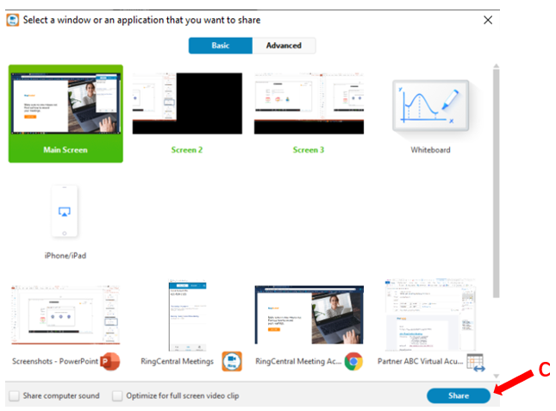

- Invite Others: This will allow you to invite others to the Virtual Lunch & Learn
  - Click the “Invite Others” button
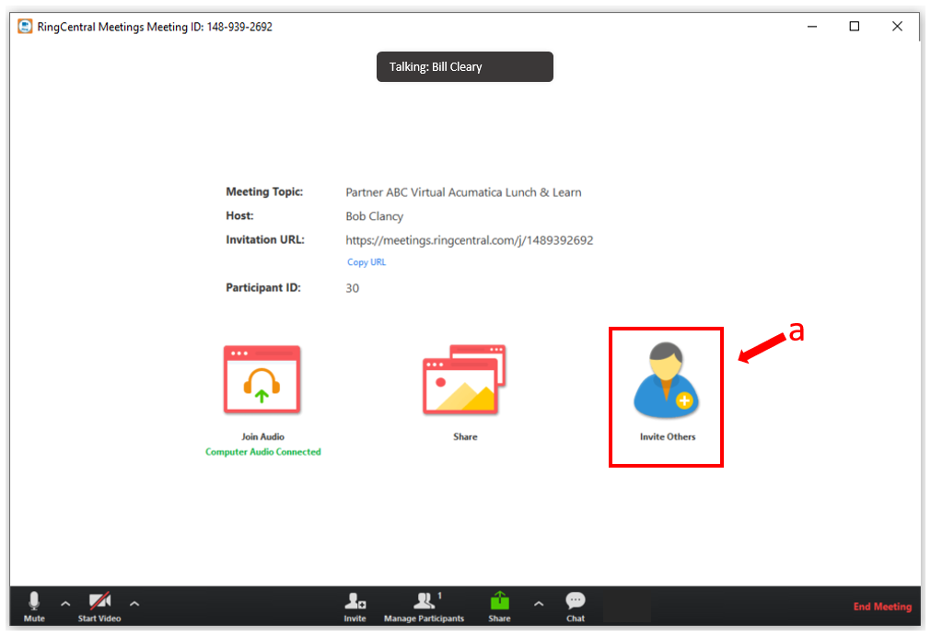
  - A window will open that will allow you to
    - Send an invite from your default email (ex. Outlook)
    - Send an invite from Gmail
    - Send an invite from Yahoo Mail
    - Copy the URL
    - Copy the invitation
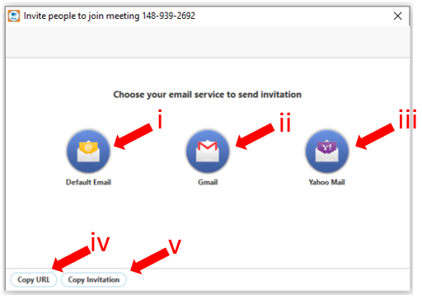

- Manage Participants: Clicking the “Manage Participants” button (1) on the toolbar will open the Participants pane on the right. From here you can:
  - View the entire list of participants
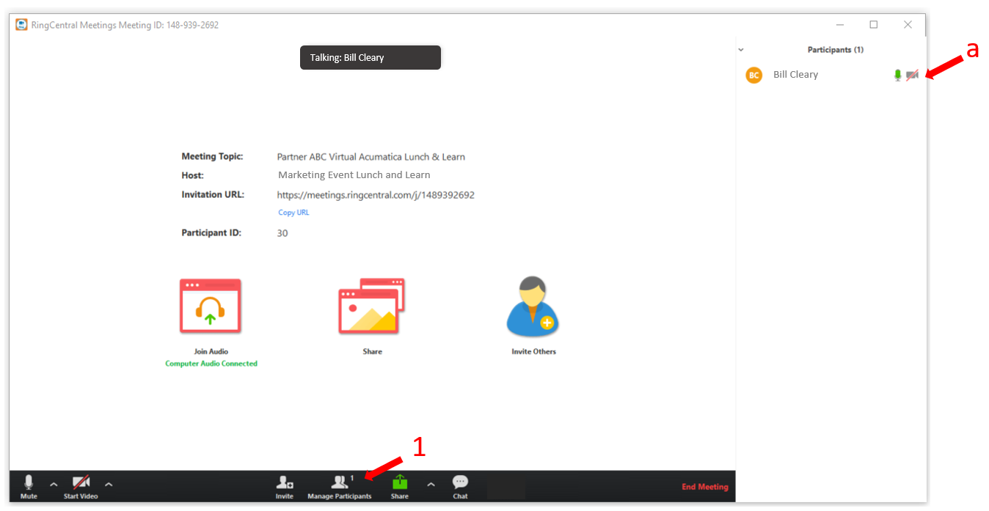
- “Chat” button
  - Will open the “Chat” pane and allow participants to type messages to be viewed and responded too
